Bloomington Community Foundation Legacy Award Nomination

The Bloomington Community Foundation is seeking nominations for its Annual Legacy Award. The Award is presented annually to an outstanding Bloomington citizen. A very special event honoring the recipient will be held in November.

Please consider the following criteria when placing a nomination for the Legacy Award:

- A record of notable achievements benefiting the Bloomington community
- Community leadership
- High ethical standards
- A history of involvement in a variety of Bloomington community activities and
organizations
- Support for community projects
- Involvement in community challenges

Nominee: ______________________________________________________________________

Noting the above criteria, attach a separate sheet describing the achievements of the Nominee and why this individual deserves the Legacy Award.

Your name, address and phone number: ___________________________________
___________________________________
___________________________________
___________________________________

Nomination deadline: September 1

Please send, fax or email your Mail: Bloomington Community Foundation completed nomination form to: P.O. Box 385907
Bloomington, MN 55438
Fax: 952-842-1707
Email: msmith@larkinhoffman.com

More Information: Phone: 952-896-3270
Website: www.bloomingtonfoundation-mn.org

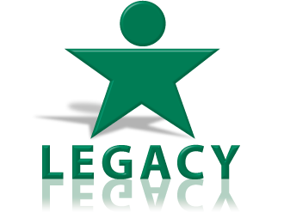
Past award recipients are:

Robert “Bob” Erickson – 2019
Bob & Sally Purvis – 2018
MaryAnne London – 2017
Joan Black – 2016
Allan and Debby Schneider – 2015
Susan Neis – 2014
David Fong – 2013
Vonda Kelly – 2012
Alice Seagren – 2011
Ron Have – 2010
Flora Tsukayama – 2009
John Laux – 2008
Arlene Bush – 2007
Bob Peters – 2006
Coral Houle – 2005
Arnie Johnson – 2004
Fran Heitzman – 2003
Diane Darr – 2002
Jan and Marty Chorzempa – 2001
Don Groen – 2000
Robert Hoffman – 1999
Jim Lindau – 1998

